Multiple Choice Questions

1. In a Monopoly market, the seller reacts to price as

1. Price Influencers
2. Price Finders
3. Price Takers
4. Price Setters

2. If a Monopoly is unable to cover its short run variable costs, it should-

1. Shut down
2. Raise the price
3. Lower the price
4. Increase the price
5. Reduce output

3.

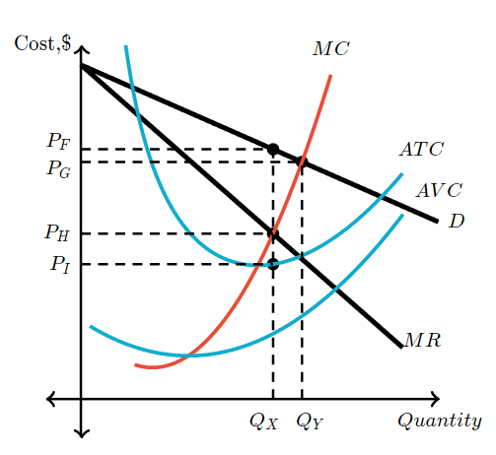

What price and quantity will this single price monopolist charge?

1. PH:QY
2. PH:QX
3. PI:QY
4. PF:QX
5. PG:QY

4. Which of the following is true in the long run for both monopoly and competitive industries?

1. Firms produce at levels that are economically efficient
2. Firms will go out of business if they cannot charge a price that is at least equal to the average total cost.
3. There are low barriers to entry
4. Firms can earn positive economic profits in the long run.

Short Question

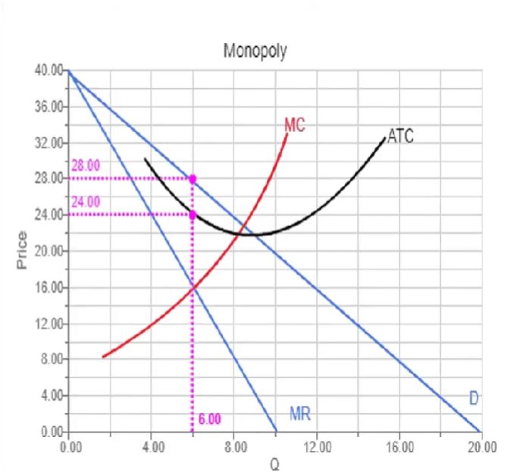

1. What is the profit maximizing output, q*? 6 units
2. What is the profit maximizing price? 28
3. Calculate TR. TR= P X Q= 28 X 6 = 168
4. What is the ATC at q*? 24
5. Calculate Total Cost. TC= 24 X 6=144
6. Calculate the Profit. PROFIT= TR-TC= 168-144= 24

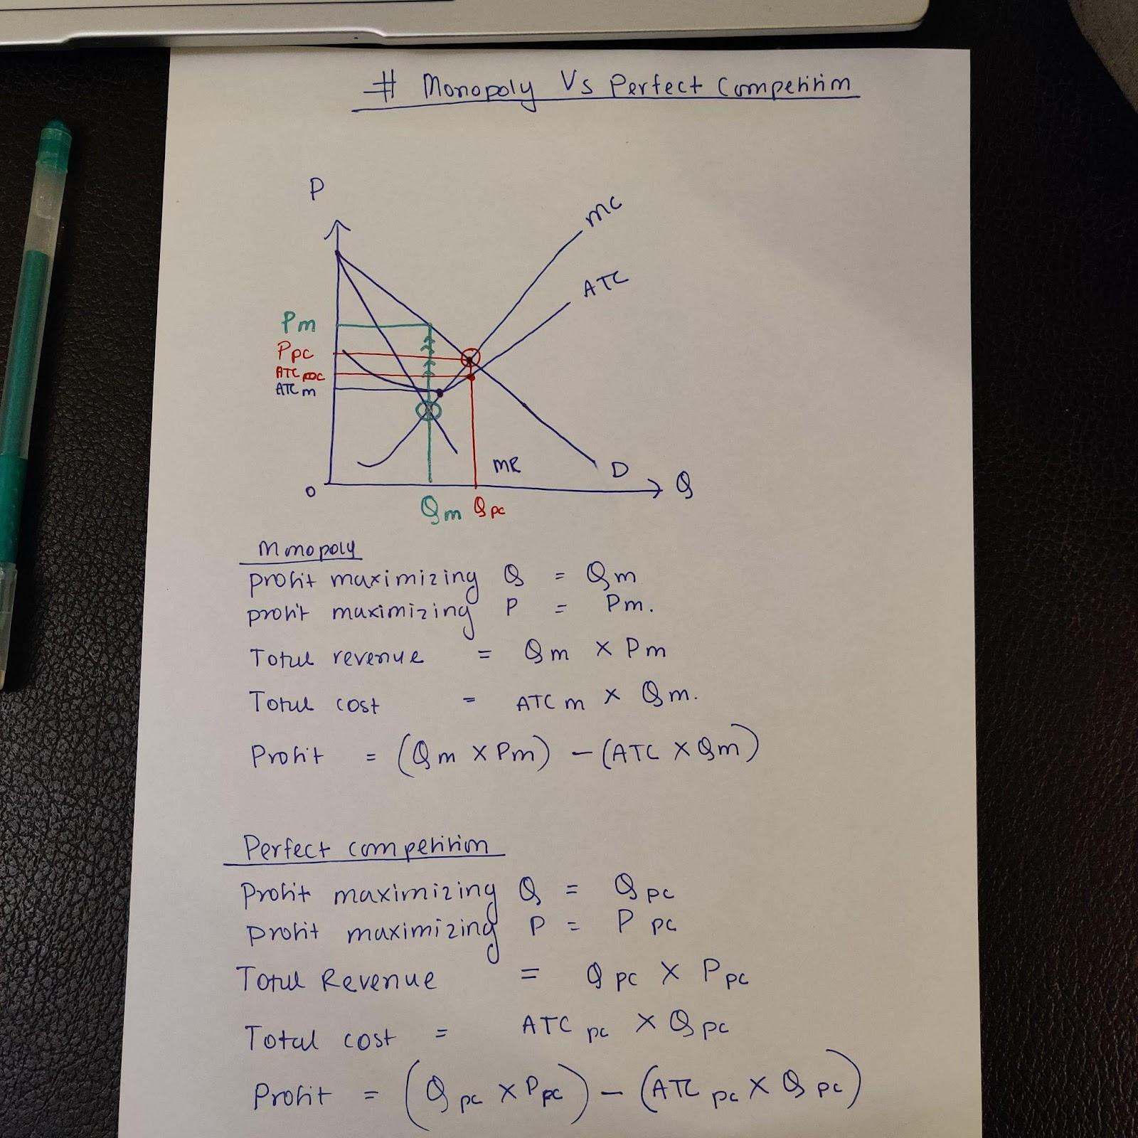

2. Suppose there is a perfectly competitive industry where all the firms are identical with identical cost curves. Furthermore, suppose that a representative firm’s total cost is given by the equation $$TC=100+q^{2}+q$$, where *q* is the quantity of output produced by the firm.

You also know that the market demand for this product is given by the equation $$P=1000−2Q$$, where *Q* is the market quantity. In addition, you are told that the market supply curve is given by the equation P = 100 + Q.

a. What is the equilibrium quantity and price in this market given this information?

Market demand= P=1000-2Q

MARKET SUPPLY= P=100+Q

MD=MS

1000-2Q=100+Q

**Q*= 300**

**P*=400**

b. The firm’s MC equation based upon its TC equation is MC = 2q + 1. Given this information and your answer in part (a), what is the firm’s profit maximizing level of production, total revenue, total cost and profit at this market equilibrium? Is this a short-run or long-run equilibrium? Explain your answer.

firm’s profit maximizing level of production:

Profit maximization condition: MR=MC

P=MR=MC

400=2q+1 so q*=199.5

Total revenue= p x q= 400 X 199.5 =79, 800

TC=100 +q^2+q= 100+(199.5)^2+199.5= 40,099.75

Profit= TR-TC= 79,800- 40,099.75=39, 700.25

IN THE LONG RUN, FIRMS OPERATE AT ZERO PROFIT. So, this is a short-run equilibrium since the firm is making positive profit.

c. Find the equation for a representative firm’s average total cost (ATC) curve. What should be the relationship between price and ATC in the long run?

TC=100 +q^2+q

ATC=TC/q= 100/q+q+1

In the long run, profit is zero, so the firm is operating at breakeven point. In the breakeven point, p=min(ATC).

2. The table contains Shell’s daily production plan of bulbs. Fill in the missing

data in the table.

|  |  |  |  |  |  |  |  |  |
| --- | --- | --- | --- | --- | --- | --- | --- | --- |
| **L** | **Q** | **MP** | **TC** | **MC** | **TFC** | **AFC** | **TVC** | **AVC** |
| 1 | 23 | 23 |  |  | 70 |  | 600 |  |
| 2 | 55 | 32 |  |  |  |  |  |  |
| 3 | 94 | 39 |  |  |  |  |  |  |
| 4 | 120 | 26 |  |  |  |  |  |  |
| 5 | 142 | 22 |  |  |  |  |  |  |
| 6 | 149 | 7 |  |  |  |  |  |  |

Will do this in last class.